1. Write a hive query to list top 5 residency details which lie in the budget of 60000-120000, an area more than 1450, sold after 17th may, min bedroom 3 and, min bathroom 2.

For this assignment we have created a table real and loaded the given data set on which the queries are expected to be executed. All the conditions are implemented on the where clause with the AND operator and the timestamp column is formatted into timestamp and the timezone and the unix­_timestamp then from_unixtime and to convert into data we use to_date and use mont and day to get the month and the day of the month so that we can get the required data from the dataset.

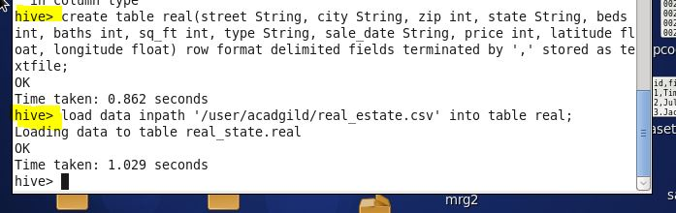

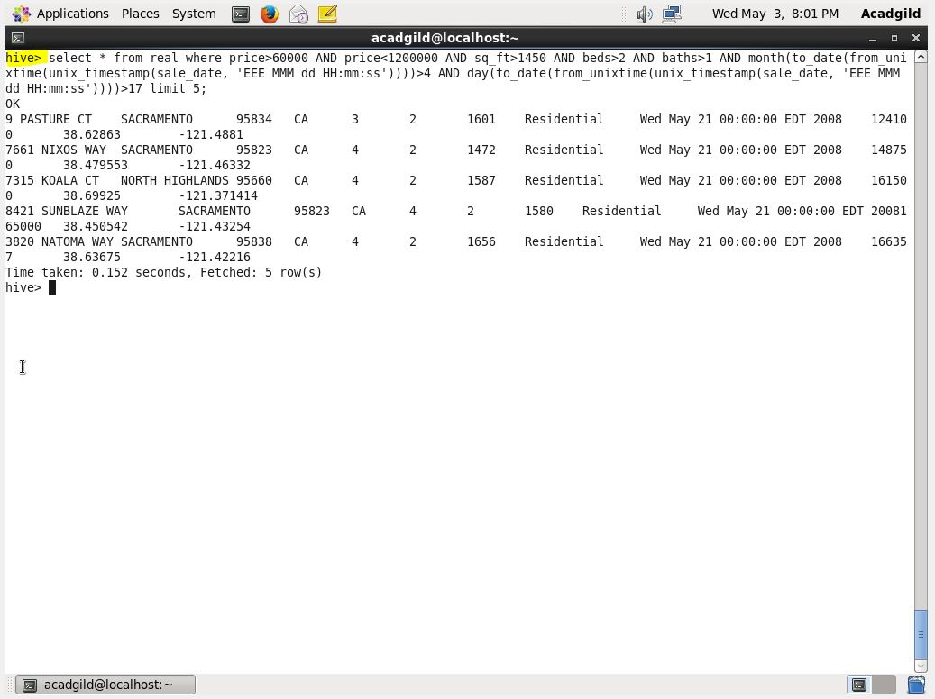

2. Write a hive query to separate list of residential apartments with more than 2 beds. Also include columns in following order City,Baths,Sq_feet,Price,flat_type,Beds respectively.

To add the columns that we want we write the name of the columns in the select query and the conditions in where clause;

